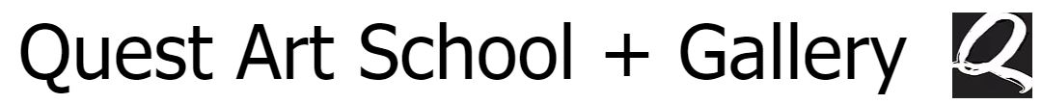

Position Available:
Audience Development Assistant
- Candidate profile
The ideal candidate would be a public relations, marketing, community planning, fine arts, museum studies student at a post-secondary level.
Candidates should be outgoing and have excellent communication skills.
Competent computers skills using MS office and social media.
Proficiency in oral and written English is necessary and in French is desirable.
In addition to the job being posted on the YCW site, it will be posted on our website and at the local employment centre as well as through out social media outlets. We will also share it on our weekly e-blast which has a subscription of 2,500+
Quest Art is an equal opportunity employer with senior staff from the Francophone community. Our job posting will encourage applicaitons for the Government of Canada's job equity groups.
We will interview in person, when possible, or via Skype or meet.google. At the conclusion of the interview, the potential candidate will be asked a series of questions to ensure they are eligible for the YCW programme.

Please apply through:
- Program stream:
Young Canada Works in Heritage Organizations
- Job title:
Audience Development Assistant
- Organization name:
Quest Art School + Gallery
- Job location:
Midland, ON
- Length of assignment: 12 weeks
2020-07-20 - 2020-10-16
- Hourly wage:
$14.00 – 35 hours per week

Quest Art School + Gallery acknowledges, and the Town of Midland recognizes, that it is located on land which is the traditional and Treaty territory of the Anishinabek people, now known as the Chippewa Tri-Council comprised of Beausoleil First Nation, Rama First Nation, and the Georgina Island First Nation. This territory is within the pre-confederation Treaty 5 and Treaty 16 and is included within the Williams Treaties of 1923. Several Treaties of Peace were made on a Nation to Nation basis between the Crown, the Anishinabek and the Haudenosaunee peoples. The Dish with One Spoon Waumpum Belt and the Five Council Fire Waumpum Belt speak upon the peace agreements between these two Nations. We also recognize that we are located on land which was once the traditional territory of the Huron-Wendat and that our community is home to many citizens of the Metis Nation of Ontario and to a large and diverse community of Indigenous peoples.

For further information please contact:

Virginia Eichhorn
Executive Director
virginia@questart.ca

